**Online Smart Chef Services**

**MUQADUS UMAR**

**ATTIQUE UR REHMAN**



DEPARTMENT OF COMPUTER SCIENCES

COMSATS UNIVERSITY ISLAMABAD,

ATTOCK CAMPUS – PAKISTAN

SESSION 2017-2021

**Online Smart Chef Services**

*Undertaken By:*

**MUQADUS UMAR**

CIIT/FA17-BCS-019/ATK

**ATTIQUE UR REHMAN**

CIIT/FA17-BCS-025/ATK

*Supervised By:*

**Dr. MUHAMMAD TAHIR**

A DISSERTATION SUBMITTED AS A PARTIAL FULFILLMENT OF THE REQUIREMENTS FOR THE DEGREE OF BACHELOR OF SCIENCE IN

SOFTWARE ENGINEERING

SESSION 2017-2021

DEPARTMENT OF COMPUTER SCIENCES

COMSATS UNIVERSITY ISLAMABAD,

ATTOCK CAMPUS – PAKISTAN

|  |  |  |  |  |  |  |
| --- | --- | --- | --- | --- | --- | --- |
| **PROJECT ID** | |  | |  | **NUMBER OF MEMBERS** | 2 |
| 222 | | | | | | |
| **TITLE** | Online Smart Chef Services | | | | | |
|  | | | | | | |
| **SUPERVISOR NAME** | | | Mam Anum Zahra | | | |

|  |  |  |
| --- | --- | --- |
| **MEMBER NAME** | **REG. NO.** | **EMAIL ADDRESS** |
| MUQADUS UMAR | CIIT/FA17-BS(CS)-019/ATK | muqadusumar@gmail.com |
| **ATTIQUE UR REHMAN** | CIIT/FA17-BS(CS)-025/ATK | attiqueurrehman12@gmail.com |

**CHECKLIST:**

|  |  |  |  |
| --- | --- | --- | --- |
| Number of pages in this report |  |  |  |
| I/We have enclosed the soft-copy of this document along-with the codes and scripts created by myself/ourselves | **YES / NO** | | |
| My/Our supervisor has attested the attached document | **YES / NO** | | |
| I/We confirm to state that this project is free from any type of plagiarism and misuse of copyrighted material | **YES / NO** | | |

|  |  |  |
| --- | --- | --- |
| **MEMBERS’ SIGNATURES** |  | |
|  |  | Supervisor’s Signature |
|  |  |
|  |  |

This work, entitled **“Online Smart Chef Service”** has been approved for the award of

**Bachelors of Science in Computer Science**

***Committee:***

1. External Examiner ____________________________

2. Supervisor ____________________________

1. Head of Department ____________________________

UNDERTAKEN

We certify that this is my/our own work. The work has not, in whole or in part, been presented elsewhere for assessment. Where material has been used from other sources it has been properly acknowledged. If this statement is untrue, we acknowledge that we will have committed an assessment offence and shall be liable to punishable action under the plagiarism rules of HEC.

______________ ____________________

Muqadus Umar Attique ur Rehman

FA17-BCS-019 FA17-BCS-025

Dated: _________ Dated: _________

**ACKNOWLEDGEMENT**

We are thankful to ALLAH Almighty the most beneficent and the merciful. May Allah shower all his blessing on us. We are grateful to ALLAH that he has provided us different types of resources and make us eligible to advantages from these resources to help human beings.

We are grateful for all that our parents do for us, there is no way of repaying them. We are really thankful for their support and their prayers, without them we are nothing. We are always supported and motivated by them in every condition of life whether it is finically.

We are thankful to **Miss Anum Zahra** for his guidance and motivating us to work hard. He has supported us on every step. Without his help we would not able to achieve this goal. We found him very helpful while discussing the issues.

**ABSTRACT**

Online Smart Chef Services is an android application that is used to provide a freelancing platform for super chef’s. Its main objective is that to provide the ease to earn money and opportunities to chefs along with the less time consumptions of the clients. It provides a feedback system in order to rate the items. Moreover, it provides a recommendation systems chef wise, customer wise and the area wise i-e Recommendation of nearby chef to users and recommendation of local dishes, events based upon reviews and ratings and the easy profile management for the chefs and the customers.

Chefs can create their profile and add skills into it in the form of images or videos with the descriptions etc. It is designed to quick access and manage an online menu and orders available Customers can browse check payments, orders, details and to place orders with a few clicks.

**Contents**

Chapter 1 1

Introduction 1

1. Introduction 2

1.1. Problem Statement 2

1.2. Solution to the Problem 3

1.3. Objective 3

1.4. Benefits 3

Chapter 2 5

Literature Review 5

2. Literature Review 6

2.1. Existing Applications 6

2.1.1. Foodpanda 7

2.1.2. Zomato 7

2.1.3. Swiggy 8

2.1.6. Drawbacks Existing Applications 10

Chapter 3 11

Requirement Analysis 11

3. Requirement Analysis 12

3.1.1. Registration for Users 12

3.1.2. Login for customers 13

3.1.3. Login for Admin 13

3.1.4. Customer Location 14

3.1.5. Placing Order 14

3.1.6. Search Bar 15

3.2. Non-Functional Requirements 15

3.2.1. Reliability 15

3.2.2. Availability 15

3.2.3. Robustness 15

3.2.4. System Modification 15

3.2.5. Security 16

3.2.6. Resource Issues 16

3.2.7. Hardware Consideration 16

Chapter 4 17

Design & Architecture 17

4.1. Architecture 18

4.2. Methodology 18

4.2.1. First Increment: 19

4.2.2. Second Increment: 19

4.2.3. Third Increment: 19

4.2.4. Fourth Increment: 19

4.2.5. Fifth Increment: 19

4.3. Use Case Diagram 20

4.3.1. Customer Use Case 20

4.3.2. Chef Use Case 21

4.3.3. Admin Use Case 22

4.4. Architecture Overview 22

4.4.1. Customer Activity Diagram 23

4.4.2. Chef Activity Diagram 24

4.4.3. Admin Activity Diagram 25

4.5. Sequence Diagram 26

The sequence diagram is as follow 26

4.6. Class Diagram 29

Appendix A 30

List of Reference 30

**Table of Figures**

Figure 2. 1 Foodpanda 7

Figure 2. 2 Zomato 7

Figure 2. 3 Swiggy 8

Figure 2. 4 Faasos 9

Figure 2. 5 SooperChef 9

Figure 4. 1 Incremental SDLC Model 18

Figure 4. 2 Customer Use Case 20

Figure 4. 3 Chef Use Case 21

Figure 4. 4 Admin Use Case 22

Figure 4. 5 Customer Activity Diagram 23

Figure 4. 6 Chef Activity Diagram 24

Figure 4. 7 Admin Activity Diagram 25

Figure 4. 8 Customer Sequence Diagram 26

Figure 4. 9 Chef Sequence Diagram 27

Figure 4. 10 Admin Sequence Diagram 28

Figure 4. 11Class Diagram 29

**Table of Tables**

Table 3. 1 FR of Users Registration 12

Table 3. 2 FR of Login Customers 13

Table 3. 3 FR of Admin Login 13

Table 3. 4 FR of Users Location 14

Table 3. 5 FR of Placing Order 14

Table 3. 6 FR of Search Bar 15

**Chapter 1**

**Introduction**

# **Introduction**

With the fast improvement of data innovation, Android applications have been expanding in recent years. Our project is based upon an android application **“Online Smart Chef Services”**that simplifies the process for both the chefs and the customers. Register as a chef to show your work to customers for feedback on Chef’s recipes. The customer easily orders any menu for marriages and parties. The System displays an intuitive and up-to-date menu with all available options in an easy to use way along with the particular recommendations. The recommendation systems for chef wise, customer wise and the area wise i-e Recommendation of chef to users and recommendation of local dishes, events based upon reviews and ratings and the easy profile management for the chefs and the customers.

Customers can view all the orders and the request confirmation details in the cart. Once the order is set it is entered into the database and cover in essential constant. This allows chefs to rapidly experience the orders as they are received and process all orders efficiently and effectively with minimal delays and confusion. The Background Management stage in this application was intended for the executive. The Administrator will have the option to oversee food dishes, dish orders, and other handle request details.

* 1. **Problem Statement**

This case study looks at the problem of the ordering process, In the existing application there are few issues:

* For putting in any requests clients need to visit hotels or restaurants to think about food things and at that point place request and pay. In this strategy, time and manual work is required.
* While putting in a request via telephone, client comes up short on the actual duplicate of the menu item, absence of visual affirmation that the request was put accurately.
  1. **Solution to the Problem**

Today as we know that android phone users are increasing rapidly. To solve this problem, we proposed to develop an android application “Online Smart Chef Services”, originally designed for a small-scale business. The main advantages of my system are that it greatly simplifies the ordering process for both the customer and chefs;

* Provide an online android based application for general clients and chefs.
* Without wasting time easily online book recipe and not to come the place.
* For more secured ordering separate accounts are maintained for each user by providing them an ID and a password.
* The system will be less likely to commit errors since it's a machine.
  1. **Objective**

The main goal of the project is to provide an interface for chefs and clients of Online Smart Chef Services.

* This application for chefs and clients without wasting time, an admin is allowed to hire a chef when required, and customers easily online book recipes.
* The admin and the users can check reviews about the new chef at any order to judge performance with the help of other user’s feedback.
* To build up a application that will surely satisfy the customer and managed a large number of orders or requests at a time accepted (one after another).
* To develop an effective and efficient application for different users.
  1. **Benefits**
     1. **Time Saving:**

Our main focus is on time because time is what we want most, but we use the worst. Order food online through an application is additionally an efficient alternative, particularly when you don't have the opportunity to visit a restaurant, hold on to get to the table, and afterward eat. Through the application, the comfort for clients has expanded a great deal, you can arrange food in minutes, get it conveyed to your home, and eat at the comfort of your place, and also allows chefs to rapidly experience the orders as they are received and process all orders efficiently and effectively with minimal delays.

* + 1. **Reliability:**

It’s a reliable platform where people can interact with each other regarding their client and chef of their recipe and it is also a reliable source for those who want to do business one can individually start his business. They can register themselves as a company and start their business.

* + 1. **Efficient**

If there is any problem or query to any customer, he/she can directly contact to us we will efficiently reply in about half-hour and solve their queries.

**Chapter 2**

**Literature Review**

## **Literature Review**

There are many such popular android applications used around the globe by restaurants. These apps vary in their features and details according to their use and region. We did extensive research and found only similar apps being used in India. Some of them are Pakistan’s apps but most apps are used for India. In our application, we have added a few new functionalities which are not in other existing apps like recommendation system for user and chef.

## **Existing Applications**

In a current application for providing any requests, a client ought to visit Hotels or Restaurants to think about food things and at that point provide requests and pay ahead of time or you need to choose a menu and submit a request accessible if the need arises. In this technique, time and manual work is required. Keeping up basic data in the records and manuals is loaded with hazard and monotonous cycle. Following of Delivery isn't accessible in past applications and Booking of a specific table ahead of time is likewise not accessible. Customization of Order, Current status of the request isn't accessible. A few applications contain an obsolete information base that is restaurant is shut, yet it shows on the application.

There are right now 4 applications are in a pattern which are Food panda, Zomato, Swiggy, Faasos. By analyzing the study, we come to the choice that Swiggy and Faasos require 30% of follow-up with respect to the request is put or not? What's more, a request is dispatched or not? What's more, if there should arise an occurrence of Foodpanda and Zomato requires less development. At present there are four sorts of the application are accessible in which manual food requesting application and server paging application are obsolete though contact screen and contact cushion projection requesting application. By noticing the outline we come to realize that Food panda and Faasos are giving numerous highlights, for example, reward focuses, e-wallet, limits, coupons, simple merchandise exchange, quality food. While Zomato and Swiggy give fewer highlights.

## **Foodpanda**

Foodpanda measures and sends arranges straightforwardly to partner restaurants, at that point conveys the suppers by conveyance riders to the clients. The administration is accessible through its sites and versatile applications. It interfaces clients with restaurants that offer food delivery in their general vicinity and allows them to pick, request, and pay on the web.

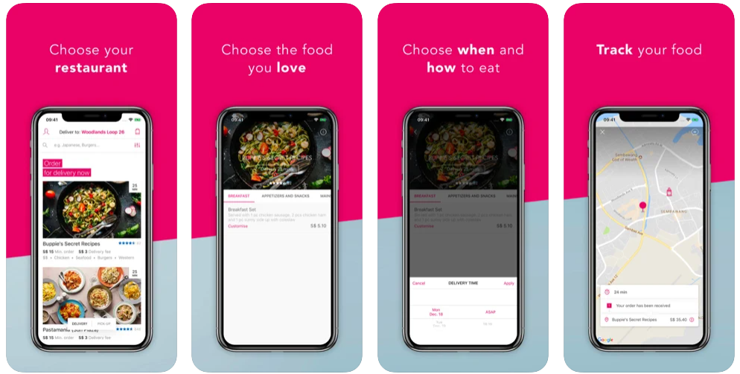

Figure 2. 1 Foodpanda

## **Zomato**

Zomato is an Indian restaurant aggregator and food delivery fire up established by Deepinder Goyal and Pankaj Chaddah. Zomato gives data, menus, and client surveys of restaurants just as food conveyance alternatives from accomplice restaurants in select urban communities.

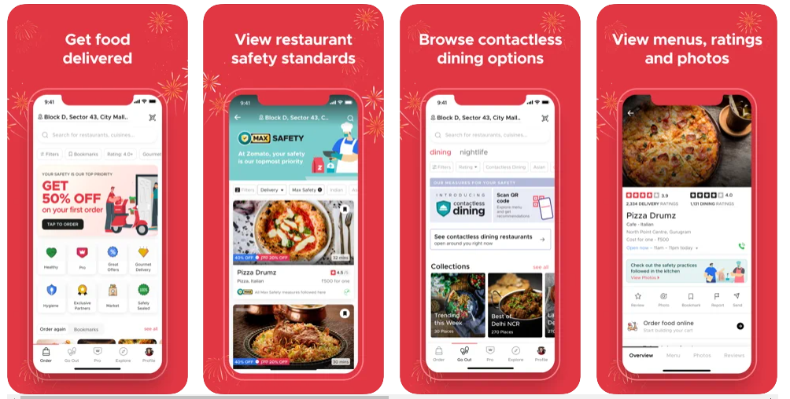

Figure 2. 2 Zomato

* + 1. **Swiggy**

Swiggy is India's biggest and most noteworthy esteemed online food requesting and conveyance stage. Swiggy is situated in Bangalore, India, and as of March 2019, was working in 100 Indian cities. Swiggy ventured into general item conveyances under the name Swiggy Stores.

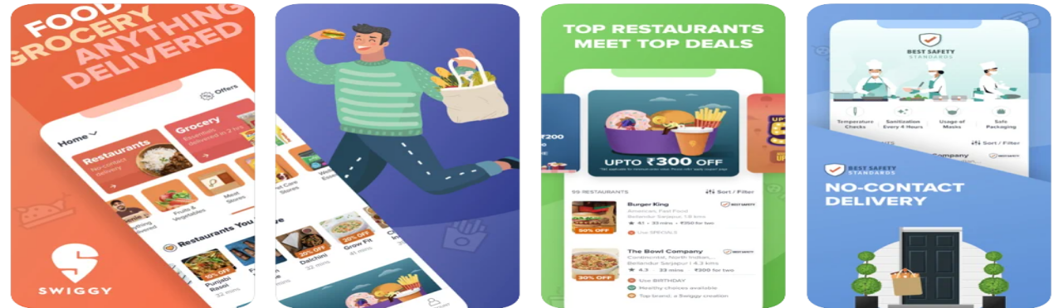

Figure 2. 3 Swiggy

* + 1. **Faasos**

Faasos is an Indian "food on interest" administration that was fused in 2011. It is one of the brands possessed by the online eatery organization, Rebel Foods. Faasos works in Dubai and 34 of the biggest urban areas in India and takes client orders through its portable application and site. It is the main vertically coordinated food business in India and works each of the three phases of a "food on interest" business: requesting, dispersion, and request fulfillment.

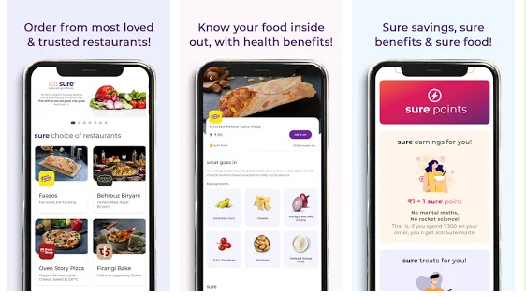

Figure 2. 4 Faasos

* + 1. **SooperChef**

SooperChef is a great food recipe app. Discover and plan from your #1 Food plans from abroad and mouth-watering scope of cooking plans. We give you an extreme answer to make your dinner plans for the entire month with our moment Food preparing plans.

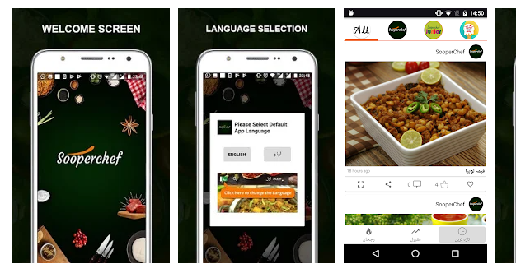

Figure 2. 5 SooperChef

## **Drawbacks Existing Applications**

1. No one shows the current status of delivery.
2. Mismatch in the delivery expected time.
3. Multiple functionalities are not available in a single application.
4. No Direct communication between chef and customer.
5. Websites are overloaded with a lot of irrelevant data.
6. Outdated information.

**Proposed System:**

In this project, we solve many problems like difficult user interface problems, a problem in easily ordering food after evaluating systems and applications.

In our application there many unique features available. The customer easily orders the food and the chef easily takes many orders at a time. Chef and customer can easily communicate with each other and order foods without any problem. In this application, we add a Recommender system for both of us according to their interest.

**Chapter 3**

**Requirement Analysis**

### **3. Requirement Analysis**

This chapter explains the functional and non-functional requirements of the software which we are developing. The functional requirement will explain what the system is expected to do. The functional requirement explains the behavior of our system and it’s component-based on a particular input. It will explain diagrammatically the incoming chapter by using the use case diagrams. This requirement will tell what our system is supposed to do. These requirements are tested in the testing phase and the result will be obtained which will be used in the assessment. These explain the behavior of our system while the non-functional requirement is the constraints. The non-functional requirement will be fulfilled to make our system is more efficient and effective. It defines the attribute of the system. At the end of this chapter, the hardware and software implementation will be explained. Before going to functional and non-functional requirements we see some terminologies which are given below. Let us discuss in detail;

**3.1. Functional Requirement**

This section will provide you with information about the functional requirements of the project.

### **3.1.1. Registration for Users**

Table 3. 1 FR of Users Registration

|  |  |
| --- | --- |
| Name | **FR-1: Registration** |
| Summary | User must register him/herself with a pic to see the functionalities of  “Online Smart Chef Services”. |
| Rationale | To keep the data of app user will be separate. |
| Requirements | User will be entered in-app by giving the Name ,Email , password and phone number,CNIC, location with the type (Chef, Customer). |

### **3.1.2. Login for customers**

Table 3. 2 FR of Login Customers

|  |  |
| --- | --- |
| Name | **FR-2: Login** |
| Summary | User Must be Login On “Online Smart Chef Services” application to see chef details then hire,order food.,view all type of dishes, to check own profile. |
| Rationale | To Keep track of the user activities and store it in an application for future use. |
| Requirements | User will be entered in Application by giving correct email and password |

### **3.1.3. Login for Admin**

Table 3. 3 FR of Admin Login

|  |  |
| --- | --- |
| Name | **FR-3: Login for Admin** |
| Summary | An Admin must be login to use the functionalities of Online Smart Chef Services. |
| Rationale | To keep the data of each user separately. |
| Requirements | The admin see all accounts and update your account, approve or disapprove requests for chef and customer, view order details. |

### **3.1.4. Customer Location**

Table 3. 4 FR of Users Location

|  |  |
| --- | --- |
| Name | **FR-7: Users Location** |
| Summary | User can mention the exact location of their place. |
| Rationale | To keep providing users location. |
| Requirements | Users will provide their location. |

### **3.1.5. Placing Order**

Table 3. 5 FR of Placing Order

|  |  |
| --- | --- |
| Name | **FR-8: Placing Orders** |
| Summary | Customers must place their orders. |
| Rationale | To keep the record of each user-selected items in each session. |
| Requirements | Chef will provide their location. |

### **3.1.6. Search Bar**

Table 3. 6 FR of Search Bar

|  |  |
| --- | --- |
| Name | **FR-9: Search Bar** |
| Summary | Customers must search the chef’s. |
| Rationale | To search the user and products by customer. |
| Requirements | Customer will search the person and product to hire. |

## **3.2. Non-Functional Requirements**

### **3.2.1. Reliability**

This proposed System which a developer design is more reliable, efficient, and user-friendly. Its efficiency interacts with the user. Secure access to use confidential data. The proposed system in which the developer designs are reliable as they efficiently interact with users. Secure access to confidential data.

### **3.2.2. Availability**

Internet Connection is available at any time. As availability will be provided if the internet connection will be available.

### **3.2.3. Robustness**

The system cannot be lost the app user’s information like hiring persons etc. These will be permanently stored and the user can delete it.

### **3.2.4. System Modification**

This system is more flexible and all modifications will be done by the customer, Material seller Like Add new items managing orders of a user. Auction corner is generating by the customer.

### **3.2.5. Security**

All user’s data will be Store in Goole Product Named Firebase. The only Developer can access that data. The second person cannot access the details of the Online Smart Chef Services application other than the owner.

### **3.2.6. Resource Issues**

Resources of the computer should meet the hardware considerations. Anything less than this is not enough proper functioning of the system.

### **3.2.7. Hardware Consideration**

RAM: 3GB (Minimum Required)

Free Space: 1GB (Minimum Required)

Operating System: Android (Above 5.1 Lollipop version

**Chapter 4**

**Design & Architecture**

#### **Design and Architecture**

This chapter discusses the design of the project.

* 1. **Architecture**

Here are some diagrams that will describe the basic architecture of our system, how components and activities in our system work and collaborate at regular and specified intervals.

* 1. **Methodology**

In The incremental SDLC (System Development Life Cycle) model, the project is divided into a smaller number of increments and each increment has a phase with time-lapse. The first increment is often a core product with many supplementary features in this method.

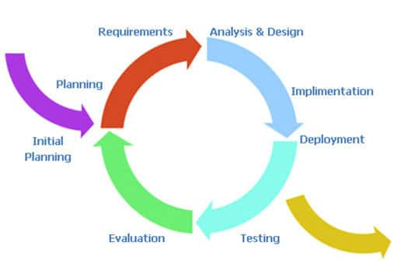

Figure 4. 1 Incremental SDLC Model

The development process model which we are using in our project is the incremental model. In this we broken project requirement into the increments for the software development cycle. We have selected this model to make projects in increments and then show the supervisor if any change is required so that can be done easily and efficiently.

### **First Increment:**

* Login For Customer
* Login For Chef
* Login For Administrator
* Registration Page for users
* Front end design of all page (prototype)

### **Second Increment:**

* Customer Module
* Searching Chef
* Uploading pic
* Updating own details
* View Chef
* Hire Chef
* Show dishes& order

### **Third Increment:**

* Chef Module
* Add Items (dishes)
* Uploading pic
* Updating own details
* View dishes
* Add recipe Videos

### **Fourth Increment:**

* Administrator Module
* Manage accounts
* Hire Chef
* Updating own details
* Approved or disapproved request
* See dishes

### **Fifth Increment:**

* App Integrating Module
* Integration with Google
* Integration with Authentication
  1. **Use Case Diagram**

The Use case diagram is a diagram that shows the behaviour of the system which we are developing. Use Case represents the functionality of the program. Actors are the primary persons who operate on the system. The actor must be associated with at least one use case.

### **Customer Use Case**

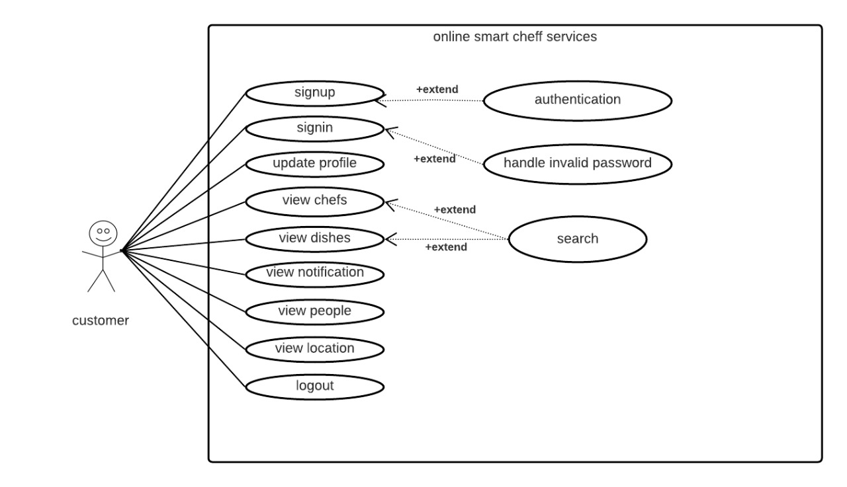

Figure 4. 2 Customer Use Case

Figure 4‑2 shows the customer behaviour of the system. The customer will be entered in the application but before he will register himself/herself. Two options Sign in and Sign up will show in front of the page. If the customer needs signup so, he will choose

signup and then login. After Login he will be seen and perform the functionalities of the system. He can update his profile. He can see chefs, dishes, recipes, and also see a notification if he hires a chef then a response will have come in a notification. He can search the person in modules. and also search for items, etc. Customers will see the location of that chef and can determine which is nearest.

### **Chef Use Case**

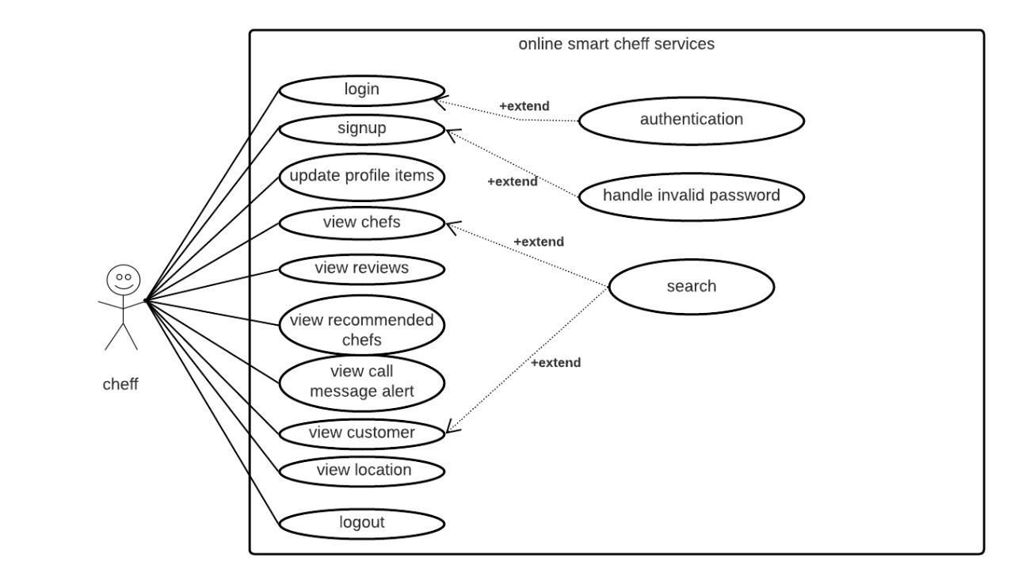

Figure 4. 3 Chef Use Case

Figure 4‑3 shows the Chef behavior of the system. The chef will be entered in the application but before he will register himself. Two options Sign In and Signup will show in front of the page. If the Chef needs signup so he will choose signup and then

login. After Login he will be seeing and perform the functionalities of the system. He can update his profile. A chef can add items, and view order requests these requests are view on the notification side. He can see all customer and their location. He can search for location and deliver food.

### **Admin Use Case**

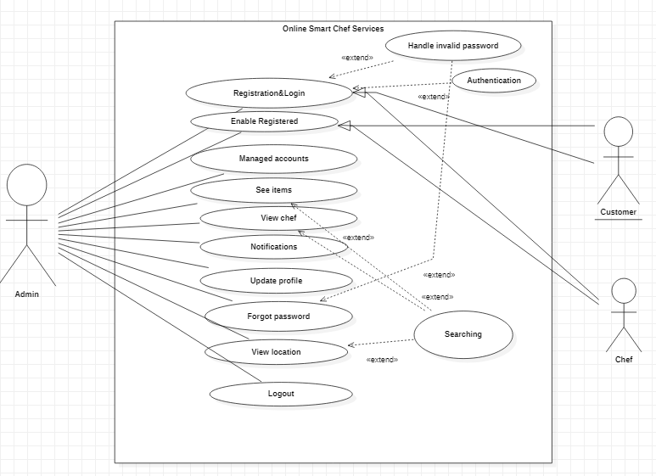

Figure 4. 4 Admin Use Case

Figure 4‑4 shows the Admin behavior of the system. Admin will be entered in an application then Login he will be seeing and perform the functionalities of the system. He can update his profile and managed all accounts. Admin can see items, and view or approve, disapprove chef request.

* 1. **Architecture Overview**

In this section, there is some diagram which will describe the architecture of over system which we are developing. The diagram will show how the system’s components interact with each other.

### **Customer Activity Diagram**

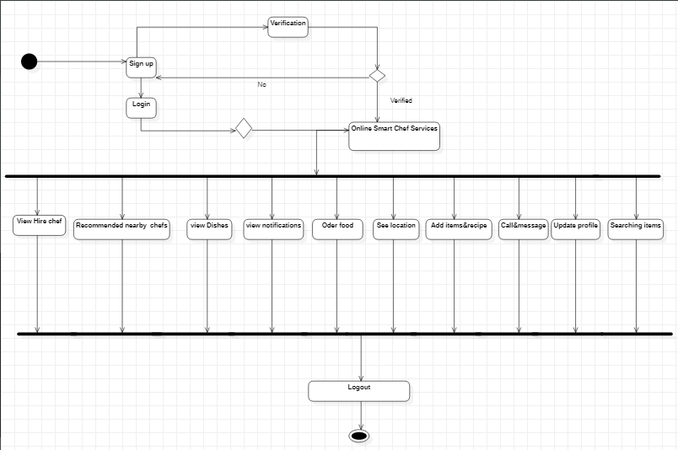

Figure 4. 5 Customer Activity Diagram

Figure 4-5 shows there is an activity performed by Customer where he simply logs in to enter in Online smart chef services app and can view Dishes, order food, searching new items, update profile. He can view their location and hire them. He also hires and sees the response of that person who hires him in a notification. The customer will add items and order food at a normal price. After performing functionalities of the app he can log out simply.

### **Chef Activity Diagram**

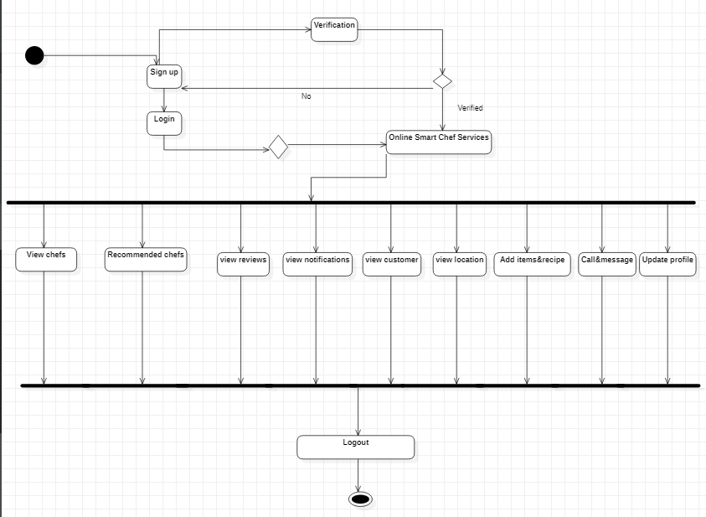

Figure 4. 6 Chef Activity Diagram

Figure 4-6 shows there is an activity performed by Chef where he simply logs in to enter in Online smart chef services app and can view chefs, reviews, notifications and also see their location. After performing functionalities of the app he can log out simply. He can see the View of the list of customer and their location. He also can see his rating. After performing functionalities of the app he can log out simply.

### **Admin Activity Diagram**

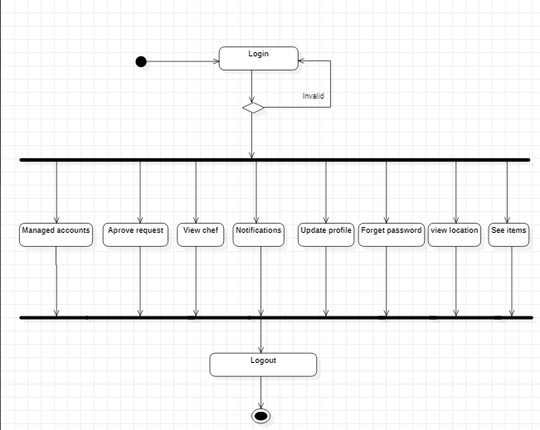

Figure 4. 7 Admin Activity Diagram

Figure 4-7 shows there is an activity performed by admin where he simply logs in to enter in Online smart chef services app. They can view the items with descriptions Like name and price, approve chef or customer request, update profile, also handle forget the password, etc. in the application. He can see the location. An admin can determine which notification is valuable. After performing functionalities of the app he can log out simply.

* 1. **Sequence Diagram**

The sequence diagram is as follow

* + 1. **Customer Sequence Diagram**

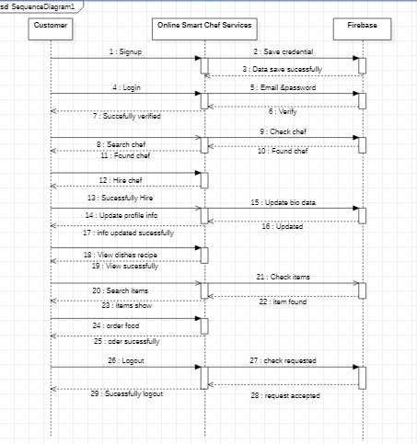

Figure 4. 8 Customer Sequence Diagram

* + 1. **Chef Sequence Diagram**

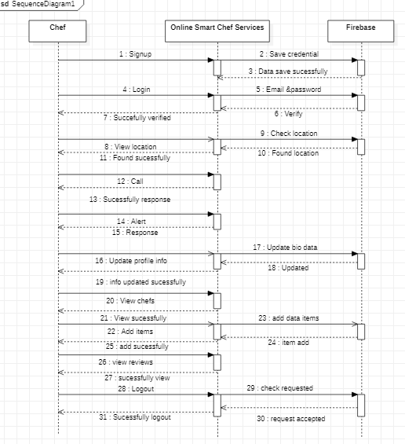

Figure 4. 9 Chef Sequence Diagram

* + 1. **Admin Sequence Diagram**

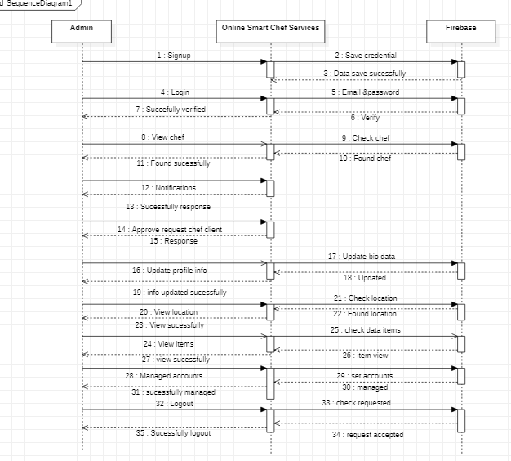

Figure 4. 10 Admin Sequence Diagram

* 1. **Class Diagram**

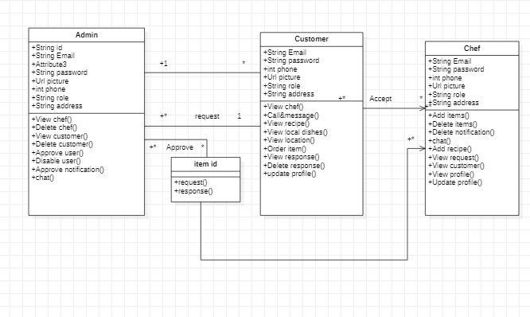

Figure 4. 11Class Diagram

**Appendix A**

**List of Reference**

1. *Location Based Services using Android Mobile Operating System by Amit Kushwaha, Vineet Kushwaha from Department of Electronics & Communication Engineering IIMT Engineering College, Meerut-250001, India. International Journal of Advances in Engineering & Technology, Mar 2011. IJAET ISSN: 2231-1963*
2. *Location Based Tracking Application Using Android Mobile Operating System by Apoorva Vengurlekar, Kiran Shukla, Dnyaneshwar J. Dhangar from Rajiv Gandhi Institute of Technology, Mumbai. International Journal of Scientific & Engineering Research, Volume 5, Issue 3, March-2014 821 ISSN 2229-5518.*
3. *Automated Food Ordering System with Interactive User Interface Approach by YoungChai Tan, KienLoong Lee, ZhiChao Khor, KaeVin Goh, KhimLengTan, BentFie Lew from Department of Engineering and Science University Tunku Abdul Rahman (UTAR),*
4. *Whitten, Jeffrey L. and Lonnie D. Bentley. (2007). System Analysis and Design Methods. (6th edition).New York: McGraw-Hill Irwin.*
5. *Yadav, Manish. (2011). History of Android. Retrieved on 10-11-2012 from http://www.tech2crack.com/history-android/*